**COMSATS University Islamabad,   
Abbottabad Campus**

**Project Proposal   
(SCOPE DOCUMENT)**

**for**

AI-Based Interview Facilitator App  
Version 2.0

***By***

**Ibrahim Khan CIIT/FA21-BSE-038/ATD**

**Um-e-Aimen CIIT/FA21-BSE-096/ATD**

**Daud Razzaq khan CIIT/FA21-BSE-112/ATD**

***Supervisor*Bushra Mushtaq**

***Bachelor of Science in Computer Science (2021-2025)***

|  |  |  |
| --- | --- | --- |
| **No.** | **Comment** | **Action** |
|  |  |  |
|  |  |  |
|  |  |  |
|  |  |  |
|  |  |  |
|  |  |  |

**SCOPE DOCUMENT REVSION HISTORY**

**Supervisor Signature**

**Date:**

**Table of Contents**

**1.** **Introduction 4**

**2.** **Problem Statement 5**

**3.** **Problem Solution for Proposed System 5**

**4.** **Related System Analysis/Literature Review 5**

**5.** **Advantages/Benefits of Proposed System 5**

**6.** **Scope 6**

**7.** **Modules 6**

7.1 Module 1: Module Name 6

7.2 Module 2: Module Name 6

**8.** **System Limitations/Constraints 6**

**9.** **Software Process Methodology 6**

**10.** **Tools and Technologies 7**

**11.** **Project Stakeholders and Roles 7**

**12.** **Team Members Individual Tasks/Work Division 8**

**13.** **Data Gathering Approach 8**

**14.** **Concepts 8**

**15.** **Gantt chart 9**

**16.** **Mockups 10**

**17.** **Conclusion 11**

**18.** **References 11**

**19.** **Plaragism Report 11**

**Project Category: (**Select all the major domains of proposed project**)**

**A-** Problem Solving and Artificial Intelligence **B-** Simulation and Modelling **C-** Smartphone Application **D-** Image Processing **E-** Desktop Application/Information System

**Abstract**

Our propose AI-Based Interview Facilitator-v2 will be developed to enhance the functionality of previous version by generation of pool of questions by other suitable AI trained model according to extracted information form candidate’s uploaded CV. Additionally, our online interview facilitation feature enables remote interviews, with real time assessment of both verbal and non-verbal verbal ques. Our app will be able to monitor facial expressions, eye contact, and can detect signs of distraction or cheating. The system assesses facial expressions and eye movements to detect nervousness, confidence, or possible distraction.

**Introduction**

In today’s competitive job market, traditional interview methods face challenges in offering a fair and objective evaluation of candidates. Human judgment can introduce biases, and remote settings often miss key non-verbal cues, such as body language and facial expressions, which can lead to an incomplete understanding of a candidate’s potential.

In order to address mentioned problems in conventional interview the proposed AI-Based Interview Facilitator-v2 will be developed to enhance the functionality by generation of pool of questions by suitable **AI trained model (using user-defined question dataset) according to extracted information from candidate’s uploaded CV.** This pool is created when a candidate uploads their CV, and the integrated OCR technology can extract key information (work experience, education, and skills) even from scanned PDFs or images. The system will then use this extracted data to generate targeted, role-relevant questions. The questions are categorized by difficulty, ensuring fairness for all candidates.

Questions are selected based on marked difficulty levels, ensuring fairness across interviews. Additionally, the new **online interview facilitation** feature enables remote interviews, with real-time assessment of both verbal and non-verbal cues.

The proposed app will be able to monitor facial expressions, eye contact, and can detect signs of distraction or cheating. It also includes customizable personas giving companies more control over the interview process. The questions used in online interviews will also be already well trained.

**Problem Statement**

As the traditional interviews often rely heavily on human judgment, which can lead to unconscious biases and overlook critical factors such as a candidate's motivation, adaptability, and communication skills under pressure. Additionally, remote interviews can be limited, as non-verbal cues like facial expressions, body language, and eye contact are difficult to capture, which can result in an incomplete assessment of the candidate.

The initial version of the *AI-Based Interview Facilitator App* attempted to address some of these issues by generating questions and evaluating answers with ChatGPT. However, this approach raised new concerns: the same question pool was often used for multiple candidates, limiting fairness and personalization, and the reliance on ChatGPT for answer assessment led to inconsistencies. Additionally, that version lacked the ability to facilitate online interviews with real-time monitoring of candidate responses.

To address these gaps, *AI-Based Interview Facilitator-v2* is being developed. This version will generate questions tailored to each candidate’s background by creating a unique dataset spanning multiple fields in CS/SE. An improved marking system will ensure that responses are evaluated accurately and consistently.

Through this project, we aim to build skills in:

* **NLP for custom question generation** based on specific roles and candidate profiles,
* **OCR technology** for extracting information from various document formats,
* **Real-time facial and emotion analysis** to detect engagement and authenticity,
* **Data processing** for live transcription and behavior tracking.

**Problem Solution for Proposed System**

The AI-Based Interview Facilitator App Version 2.0 addresses these challenges by providing a more comprehensive, AI-driven interview process. The system begins by analyzing the candidate’s CV using OCR technology to extract relevant details, such as work history, education, and specific skills. This extracted data enables the AI model to generate tailored questions that align with the candidate’s experience and the role requirements, organized by difficulty to ensure fair assessment across interviews.

For remote interview sessions, the app includes advanced functionality for real-time analysis of both verbal and non-verbal cues. The system can track facial expressions, eye contact, and potential signs of distraction, giving interviewers a more accurate view of the candidate’s engagement and responses. Interviewers can configure the interview settings and utilize the generated questions to probe specific areas, with real-time transcription and body language analysis further enhancing the evaluation process.

After the interview, the app compiles a detailed report that includes insights into the candidate’s verbal and non-verbal performance, as well as their compatibility with the role. The use of AI in both question generation and behavioral analysis helps minimize interviewer biases, making this app a fair and effective tool for modern recruitment needs.

**Related System Analysis/Literature Review**

| **Application Name** | **Weakness** | **Proposed Project Solution** |
| --- | --- | --- |
| **HireVue** | HireVue’s AI-based scoring relies on broad analysis techniques that do not fully align with role-specific skills, and facial recognition may raise concerns about bias and privacy. | Our project customizes question generation based on role requirements and applies tailored behavioral analysis to enhance candidate assessment accuracy while addressing potential biases. |
| **Interviewing.io** | Provides only mock interview feedback without offering in-depth analysis on non-verbal cues, limiting the understanding of candidates' real-time engagement and body language. | Our project incorporates real-time tracking of non-verbal cues like facial expressions and eye contact, allowing for a holistic candidate assessment in live interview settings. |
| **Sapia.ai** | Sapia.ai’s text-based analysis lacks comprehensive assessment capabilities for non-verbal interactions, which are crucial in determining candidate engagement and authenticity. | Our system adds live video analysis of non-verbal behavior, providing a more complete assessment of both verbal and non-verbal factors to enhance remote interview accuracy. |

**Advantages/Benefits of Our System**

1. **Personalized Interviews**: The AI generates questions based on the candidate’s CV, ensuring relevance and depth in the interview process.
2. **Improved Candidate Insights**: Analyzes both verbal responses and non-verbal cues, providing a more comprehensive evaluation of the candidate.
3. **Reduced Bias**: AI-driven assessments help minimize interviewer bias, promoting fairer and more objective evaluations.
4. **Efficiency**: Streamlines the interview process by tailoring questions and providing real-time transcription and analysis, saving time for interviewers.
5. **Customizable**: Allows companies to upload their own datasets and choose specific interview personas, making the tool adaptable to various industries and roles.
6. **Real-Time Feedback**: Provides immediate insights into the candidate's performance during the interview, enabling interviewers to adjust their questioning strategy as needed.
7. **Enhanced Engagement Monitoring**: By tracking non-verbal cues like facial expressions and eye contact, the system offers deeper insights into the candidate's engagement level, ensuring a more thorough assessment.
8. **Data-Driven Decision Making**: Generates detailed reports post-interview, helping hiring managers make informed decisions based on both qualitative and quantitative data.
9. **Scalable Solution**: Suitable for organizations of all sizes, the system can easily handle multiple interviews simultaneously, making it ideal for high-volume recruitment scenarios.
10. **Continuous Learning**: The AI model can evolve over time by learning from each interview session, improving question generation and evaluation processes based on past candidate performances and feedback.

**Scope**

The scope of the AI-Based Interview Facilitator App-V2 is to create an intelligent interview support tool that enhances the interview process through AI-driven question generation, CV-based analysis, and real-time assessment of both verbal and non-verbal skills. The app will use OCR to analyze candidate CVs and generate tailored interview questions based on experience, skills, and job history. These questions are categorized by difficulty, allowing for fair and standardized assessments across different candidates. **The app will not only support in-person interviews but also facilitate remote sessions, making it adaptable to modern hiring practices**.

Key functionalities include real-time transcription, facial expression analysis, and body language tracking to gauge engagement and authenticity during online interviews. The app will also support a customizable interview approach, where interviewers can upload custom datasets and choose personas—such as technical or managerial—ensuring relevance and alignment with specific job requirements. The app’s marking mechanism will evaluate responses against predefined criteria, providing objective and structured assessments.

The project does not aim to replace human judgment entirely but will assist interviewers by minimizing subjective biases and helping them gain a more complete view of each candidate's capabilities. It does not include the ability to autonomously make final hiring decisions but instead offers insights to help in the selection process. The proposed app will also require appropriate software tools like AssemblyAI for transcription, FER for non-verbal analysis, and supervised learning techniques using TensorFlow or PyTorch to implement core functionalities effectively.

**Modules of the AI-Based Interview Facilitator App-V2**

#### 1. CV Data Extraction

* **Suitability:** Both Live and Online
* **Description:** Extracts essential information from the candidate’s CV using OCR technology, capturing education, skills, and experience. This data serves as the foundation for question generation.

**2. Role-Relevant Question Generation**

* **Suitability:** Both Live and Online
* **Description:** Generates questions from the CV data, tailored to the job role, and categorizes them by difficulty. For live interviews, this module dynamically adapts as the interview progresses, while for online interviews, it provides a static dataset based on CV content.

**3. Dynamic Follow-Up Question Generation**

* **Suitability:** Live
* **Description:** During live interviews, this module formulates follow-up questions in real time, responding to the candidate’s previous answers. It enables adaptive questioning based on emerging details, enhancing interview depth.

**4. Real-Time Transcription**

* **Suitability:** Both Live and Online
* **Description:** Transcribes spoken responses during interviews, capturing both questions and answers accurately for real-time analysis and record-keeping.

**5. Session Summarization and Reporting**

* **Suitability:** Both Live and Online
* **Description:** Generates a comprehensive report summarizing the candidate’s responses, non-verbal cues, and overall performance. In live settings, this includes dynamic elements from the follow-up questions; in online settings, it compiles static question responses.

**6. Non-Verbal Analysis**

* **Suitability:** Online
* **Description:** Utilizes facial recognition to monitor expressions and engagement, such as eye movements and signs of attentiveness, providing insights into the candidate’s non-verbal cues.

**7. Behavioral and Emotional Scoring**

* **Suitability:** Online
* **Description:** Compiles data from non-verbal analysis into a behavioral score, indicating levels of confidence, attentiveness, and emotional response. This score integrates into the final online interview report.

**8. Interview Session Customization**

* **Suitability:** Online
* **Description:** Allows interviewers to configure session settings, such as selecting personas (e.g., technical, managerial) and enabling or disabling non-verbal analysis for online interviews.

**9. Candidate Data Management**

* **Suitability:** Both Live and Online
* **Description:** Maintains a database of candidate profiles, interview histories, and scores for future reference, accessible for either live or online interview sessions.

**10. Data Security and Access Control**

* **Suitability:** Both Live and Online
* **Description:** Provides secure data storage and access control, ensuring only authorized users can access sensitive candidate and interview data.

**System Limitations/Constraints**

1. **Dependence on Internet Connectivity:** For optimal functionality, particularly in online interviews, the system requires a stable internet connection. Any disruption in connectivity may impact the real-time facial recognition, transcription, and response evaluation, potentially affecting interview accuracy and the candidate’s overall experience.
2. **Language Limitation**: The system is primarily designed for interviews conducted in English. While English is widely used in professional contexts, this limitation may exclude non-English-speaking candidates and interviewers (Frayne, Burns, Hardt, Rosen, & Moskowitz, 1996). Expanding language support would require additional resources and time.
3. **Hardware Requirements**: Users must have access to compatible devices with microphones and speakers for audio input and output. This limitation may exclude individuals with older or less advanced hardware. Ensuring compatibility with a wide range of devices can be challenging.
4. **One Interviewer at a Time**: The system is designed to accommodate one interviewer speaking at a time during the interview process. This constraint ensures a clear and focused conversation but may limit scenarios involving multiple interviewers simultaneously interacting with candidates.
5. **Accuracy of Non-Verbal Cues Analysis:** Although the system uses AI for facial expression and non-verbal cue analysis, it may not fully capture nuanced expressions or cultural differences in body language. This can lead to slight misinterpretations of a candidate’s engagement or emotions.

**Software Process Methodology**

For the development of the AI-Based Interview Facilitator App-V2, we will adopt the **Agile methodology combined with an Object-Oriented Programming (OOP) approach**. Agile methodology is chosen for its flexibility and iterative nature, allowing for rapid development and continuous feedback, which is essential in refining our app's features based on user needs and testing outcomes. Utilizing OOP will facilitate better code organization, reusability, and maintenance, as we can create distinct classes for various components such as the CV parser, question generator, and facial analysis module. This combination ensures that we can quickly adapt to changing requirements while maintaining a robust and scalable architecture throughout the development process.

**Tools and Technologies**

* **AssemblyAI (Python)** for converting audio interviews into text in real-time.
* **TensorFlow** or **PyTorch** for supervised learning and custom dataset training.
* **FER (Facial Expression Recognition) library in Python** for real-time facial expression and eye-tracking to evaluate non-verbal cues.
* **React Native** for building a user-friendly mobile application interface.
* **Flask (Python)** for backend management and API integration**.**

**Project Stakeholders and Roles**

**Table 3 Project Stakeholders for Proposed Project**

|  |  |
| --- | --- |
| **Project Sponsor** | COMSATS University Islamabad, Abbottabad Campus |
| **Stakeholder** | * **Students**   Daud Razzaq  Um-e-Aimen  Ibrahim Khan   * **Project Supervisor**   Ma’am Bushra Mushtaq (Responsible for guiding, advising, and overseeing our project's progress)   * **Final Year Project Committee** |

**Team Members Individual Tasks/Work Division**

|  |  |  |
| --- | --- | --- |
| **Student Name** | **Student Registration Number** | **Responsibility/ Modules** |
| UM-E-AIMEN | FA21-BSE-038 | **Modules**: Real-Time Transcription, Candidate Data Management, Frontend for Session Customization, Session Summarization and Reporting (UI)  **Focus**: Frontend UI development, transcription display, database management, and report access controls. |
| IBRAHIM KHAN | FA21-BSE-096 | **Modules**: Dynamic Follow-Up Question Generation, Non-Verbal Analysis, Behavioral and Emotional Scoring, Interview Session Customization  **Focus**: AI-driven question generation, non-verbal cue analysis, and behavioral scoring. |
| DAUD RAZZAQ | FA21-BSE-112 | **Modules**: CV Data Extraction, Role-Relevant Question Generation, Session Summarization and Reporting, Data Security and Access Control  **Focus**: Backend development, secure data handling, and implementing OCR for CV processing. |

**Data Gathering Approach**

The development of the AI-Based Interview Facilitator App-V2 was motivated by the need to mitigate bias and subjectivity in traditional interview processes. Extensive research into existing recruitment practices revealed consistent challenges in ensuring fair assessments of candidates. To address this, we gathered data through literature reviews, surveys of HR professionals, and analysis of current interview technologies. By leveraging advancements in AI and Natural Language Processing (NLP), we aimed to create a more objective and data-driven solution that enhances the overall effectiveness and fairness of candidate evaluations.

**Concepts**

* **Machine Learning (ML)**  
  Machine Learning is essential for analyzing candidate responses and generating tailored interview questions. By training algorithms on historical data, we enhance the relevance of questions and improve the accuracy of real-time assessments during interviews.
* **Artificial Intelligence (AI)**  
  AI automates various interview processes, from generating questions based on CV data to analyzing candidate performance. This technology allows for personalized interview experiences and helps reduce bias, fostering a more equitable hiring process.
* **Software Requirements Engineering (SRE)**  
  Software Requirements Engineering involves gathering and documenting the functional and non-functional requirements of the application. This process ensures clarity and alignment among stakeholders, setting a solid foundation for successful project development.
* **Automatic Speech Recognition (ASR)**

ASR technology will play a pivotal role in our project, enabling the real-time conversion of spoken language into text. We will gain expertise in working with ASR APIs to accomplish this task seamlessly.

* **Software Quality Engineering (SQE)**  
  Software Quality Engineering focuses on maintaining quality standards throughout development. Implementing testing strategies and quality assurance practices will ensure our app functions reliably and meets user expectations.
* **Database Management System (DBMS)**  
  A robust Database Management System will be crucial for securely storing and managing interview data, user accounts, and reports. This skill will enable efficient data retrieval and ensure the integrity of sensitive information throughout the application.
* **Application Development**  
  Mobile Application Development will focus on creating a user-friendly interface for our application, ensuring accessibility for both interviewers and candidates. We will explore frameworks like React Native to build a responsive and engaging mobile experience.

**Gantt chart**

Create the Grant Chart and provide estimated start and end dates of all proposed modules/tasks for each team member. Also identify the dependencies (which tasks cannot be started/completed, until the dependent task is completed). Gantt chart can be created using MS Project.

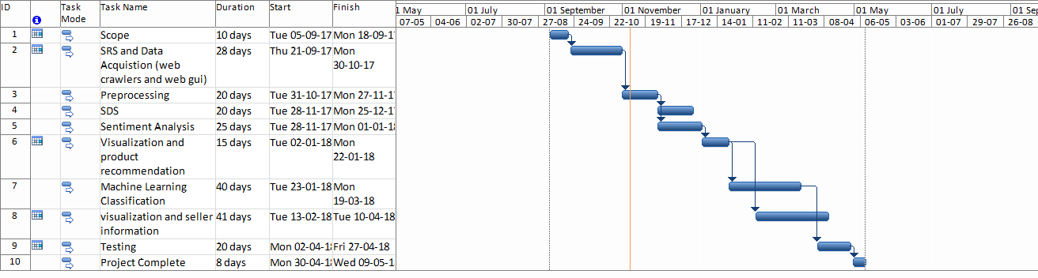

Figure 1Sample Gantt chart

**Mockups**

Insert minimum mockups (Usually 4-6 mockups) which show the major modules mentioned in the scope section of the document. Do not include mockups for Login, Signup, Forgot Password, Contact Us, About Us etc. If the project is a Web or a Smartphone Application, then include at-least three mockups from each part of the project. You can design mockup in any design tool for example pencil tool (<https://pencil.evolus.vn/>) or Balsamiq (<https://balsamiq.com/>)

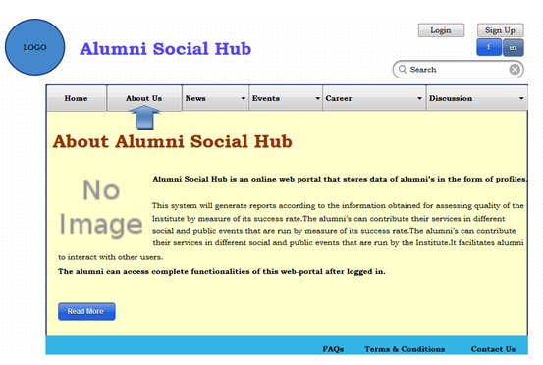

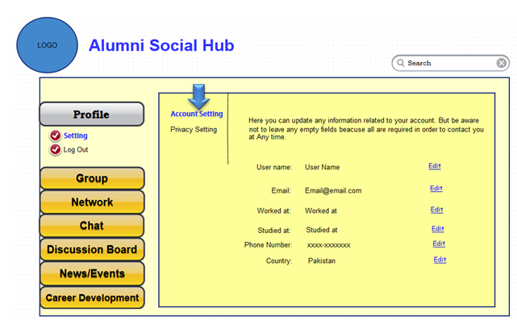

**Conclusion**

Conclude this document. (Usually 4-5 sentences)

**References**

Mention the books, research papers, web links etc.

**Plagiarism Report**

Attach the Plagiarism report of your project scope document from library staff of turnitin tool (http://turnitin.com